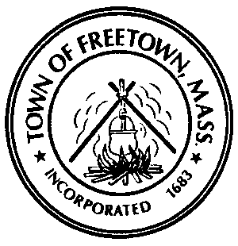

TOWN OF FREETOWN

3 NORTH MAIN STREET
P.O. BOX 438
ASSONET, MA 02702-0438

Date: June 3, 2013

PROPOSED ARTICLE – RELATIVE TO ANNUAL TOWN MEETING WARRANT

1. To see if the Town will vote to amend the Town of Freetown Protective By-laws, Article 11 Zoning By-laws, Section 11.18 Zoning Districts (I) Table of Use Regulations by including Registered Marijuana Dispensaries and Medical Marijuana Treatment Centers in the table to establish uses permitted within the Industrial II District.
See proposed changes to the table of use regulations below

Use | R | B | I | I/2 | G | OSR | VR | VB
Registered Marijuana Dispensary | N | N | N | Y | N | N | N | N
Medical Marijuana Treatment Center | N | N | N | Y | N | N | N | N

2. SUBMITTED BY: the Planning Board

3. VOTE REQUIRED: Majority Vote __ _; 2/3 Vote_X_; 4/5 Vote___;

4. EXPLANATION OF ARTICLE:
To establish a zone with the town of Freetown where a Registered Marijuana Dispensary and/or a Medical Treatment Center is an allowed use by right.

5. FUNDING SOURCE: General Fund___; Transfer of Funds Explained in Article___; Other:_X_ (Explanation:) There is no need for funds associated with this article.

(Selectmen’s Office Use only:)
SELECTMEN IN FAVOR OF ARTICLE? ___Yes ___No.

IS ARTICLE TYPICALLY SUBMITTED FOR EACH A.T.M.? ___Yes ___No

VOTED TO INCLUDE ON WARRANT? ___Yes ___No DATE:

FORM SUBMITTED TO FINANCE COMMITTEE ON:

FINANCE COMMITTEE IN FAVOR OF ARTICLE? ___Yes ___No

