Present Incumbent: Paul S.V. Campbell Date of last revision: July 2011
Title: Town Engineer Reports to: Director of Public Works
Salary Chart: I Job Grade: 17
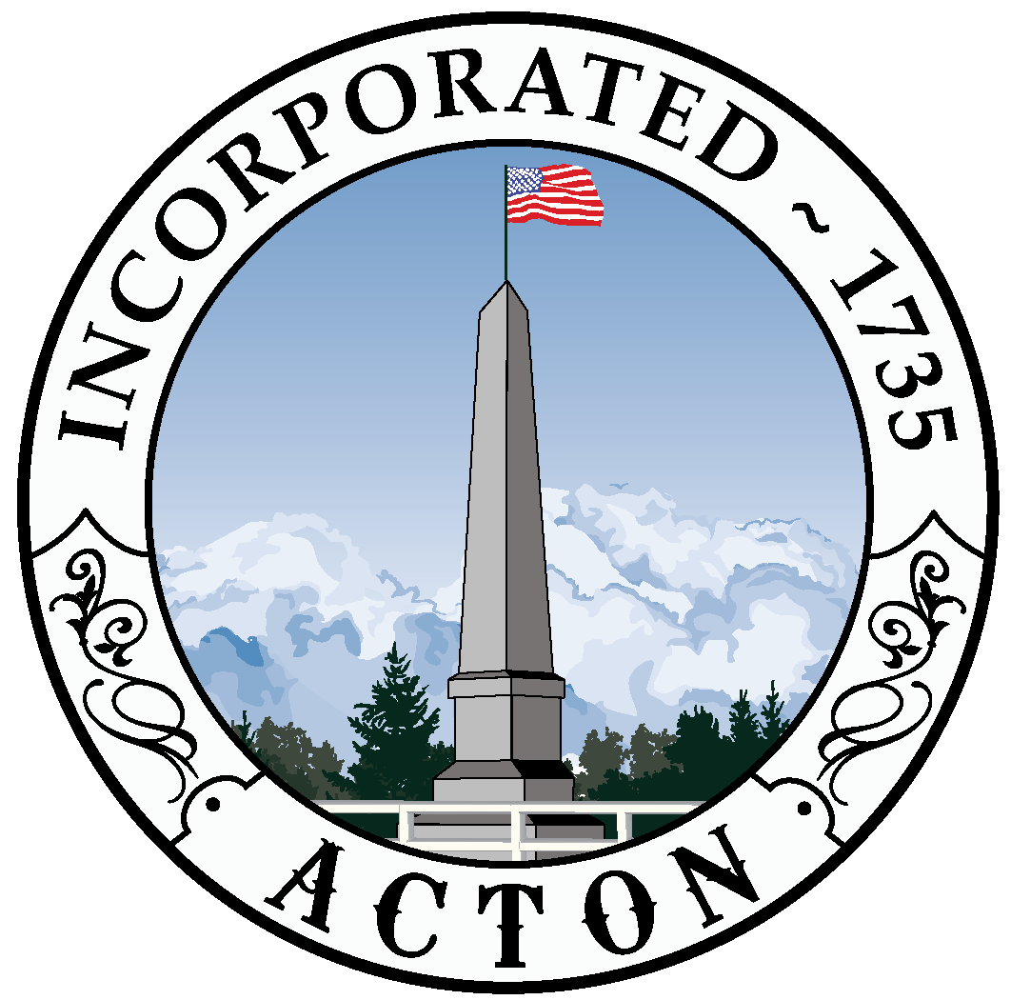TOWN OF ACTON

SUMMARY: Under the supervision of the Director of Public Works, coordinates and performs routine to complex supervisory, professional and administrative work in planning and organizing the daily activities of the Engineering Department.

SUPERVISORY RESPONSIBILITY: Supervises the Civil Engineer/Surveyor, Senior Workers and Interns.

DISTINGUISHING CHARACTERISTICS OF POSITION:

Supervisory controls: Director of Public Works sets overall objectives and works with the employee to develop priorities and goals. Employee is responsible for planning and carrying out work assignments, resolving most conflicts which arise, and coordinating the work with other employees and/or departments. Employee interprets regulations and policies on own initiative, keeping Director of Public Works informed of progress, problems, or implications of decisions. Employee frequently required to work independently.

Guidelines: Specific, detailed guidelines covering most aspects of the assignment are provided. Employee adheres to the guidelines, Town of Acton Personnel Administration Plan and major deviations must be authorized by supervisor. Many regulations and standards are available, but have gaps of specificity. Employee required to work within these broad guidelines, exercising judgment as to the best course of action. Employee uses initiative and resourcefulness in completing projects keeping the Director of Public Works informed.

Complexity: Work includes varied duties requiring many different and unrelated processes and methods applied to a broad range of activities, all within the general umbrella of civil engineering and land surveying. Decisions involve interpreting and evaluating situations in light of continuing changes, technological developments, or conflicting requirements, including budget limitations. Employee is expected to originate new techniques or approaches, establish criteria, or develop new information.

Scope and Effect: Work requires the assessment of a variety of complex conditions and situations, formulating solutions, making judgments, and evaluating the effectiveness and quality of the completed project. Errors in judgment could seriously affect the accuracy, reliability, and acceptability of department operations and services; poor public relation outcomes; substantial financial and safety problems for the Town; and, significant legal repercussions.

Personal Contacts/Purpose of Contacts: Contacts are with other employees within the department, other Town departments, various Town Committees, the general public, Contractors and various State and Federal agency representatives. Communication in person, by telephone and via standard written
communication (i.e. e-mail). Involves discussing routine to highly complex technical information as well as administrative information.

Physical Demands/Work Environment: Work is primarily sedentary, but includes some standing and walking over various surfaces, including construction sites. Employee frequently required to carry survey equipment, tools, and materials to survey sites. Work is performed under office conditions and in the field, with intermittent exposure to adverse weather conditions. Environment involves moderate risks or discomforts which require normal safety precautions.

KNOWLEDGE, SKILL AND ABILITY:

Knowledge - Knowledge of statutes, bylaws, regulations, policies and procedures relevant to public works design, bidding and construction. Knowledge of municipal government. Knowledge of GIS. Knowledge of Microsoft Office Suite. Knowledge of AutoCAD and HydroCAD.

Skill - Strong interpersonal skills. Considerable skill, diplomacy, and tact are required in interacting with the public. Conflict resolution.

Ability - Ability to recognize town-wide priorities and work cooperatively to support their accomplishments. Ability to work effectively with a diverse range of citizens and town citizen committees. Ability to read, understand, interpret and apply town and state and federal laws, regulations, policies and standards related to public works projects. Ability to read and interpret technical papers. Ability to identify and analyze issues and develop appropriate recommendations. Ability to communicate effectively and efficiently verbally and in writing. Ability to work effectively under time constraints to meet deadlines. The ability to assess a situation quickly and accurately.

MINIMUM ENTRANCE REQUIREMENTS: Bachelor’s degree in civil engineering plus five years of varied engineering experience, including construction design and supervision; or equivalent combination of education and experience. Prior supervisory experience required. Thorough knowledge of the principles and practices of civil engineering and surveying, and the materials, methods and techniques of public works construction.

PREFERRED REQUIREMENTS: Registration as a Professional Engineer and/or Land Surveyor.
Must attend night meetings.

SPECIAL REQUIREMENTS:

Licenses - None

DETAILED JOB DUTIES:

- Coordinates and performs land surveying activities with department personnel, including property surveys; easement layouts; street layouts and takings; and construction layouts.

- Under the general technical guidance of the Public Works Director, supervises department personnel in the performance of professional engineering work for the Town.

- Coordinates and performs the preparation of plans and documents for land takings and easements in connection with department construction projects.

- Performs construction inspection of streets, sewers, sidewalks, and utilities in subdivisions to insure compliance with Town construction standards and regulations.

- Prepares and supervises the preparation of feasibility studies, cost estimates and designs for various Town boards and committees on all public works related matters. Provides technical assistance and advice to a number of boards and departments.

- Assists the Director of Public Works in preparing and administering department budget.

- Supervises the maintenance of Town maps and associated files.

- Tracks, using various software applications, all Town Engineering projects.

- Perform daily office activities such as serving the public, answering inquiries, maintaining records and other office management tasks.

- Works closely with Highway Department on various DPW projects such as sidewalks, drainage and road improvements.

- Participate in public hearings and informational meetings in order to provide information or technical support on public works matters or private construction projects.

- Manage general municipal duties such as parking meter management.

- Performs related work as required.

_______________________________________________ __________________
Department Head Signature Date

_______________________________________________ __________________
Employee Signature Date

